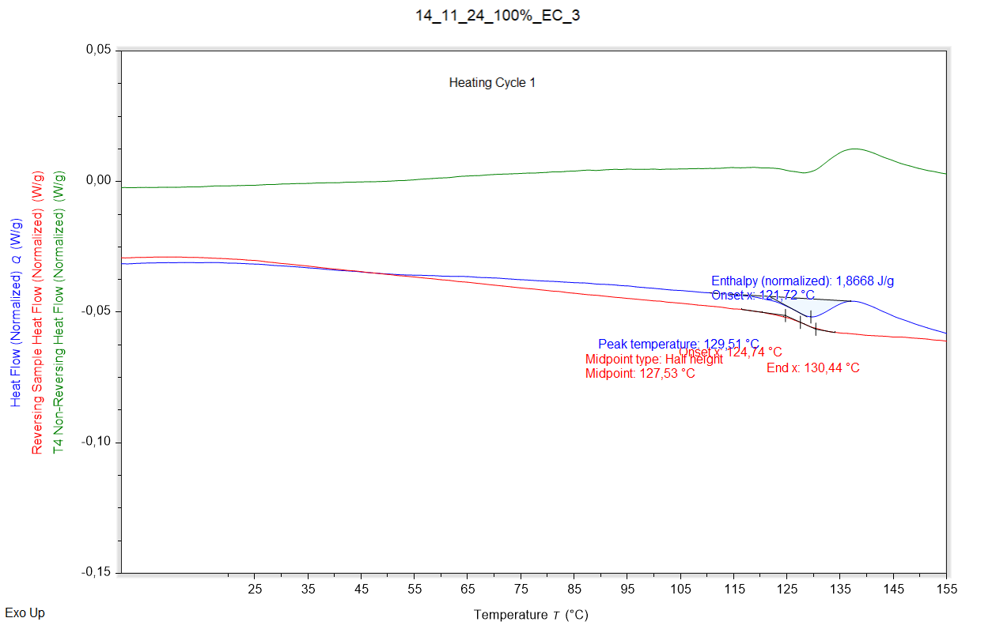

|  |  |  |  |
| --- | --- | --- | --- |
| Enthalpy recovery | Enthalpy recovery onset (°C) | Enthalpy recovery peak (°C) | Enthalpy recovery enthalpy (J/g) |
|  | 121,715 °C | 129,510 °C | 1,8668 J/g |

|  |  |  |  |
| --- | --- | --- | --- |
| Glass transition | Glass transition onset (°C) | Glass transition midpoint (°C) | Glass transition endpoint (°C) |
|  | 124,737 °C | 127,529 °C | 130,442 °C |

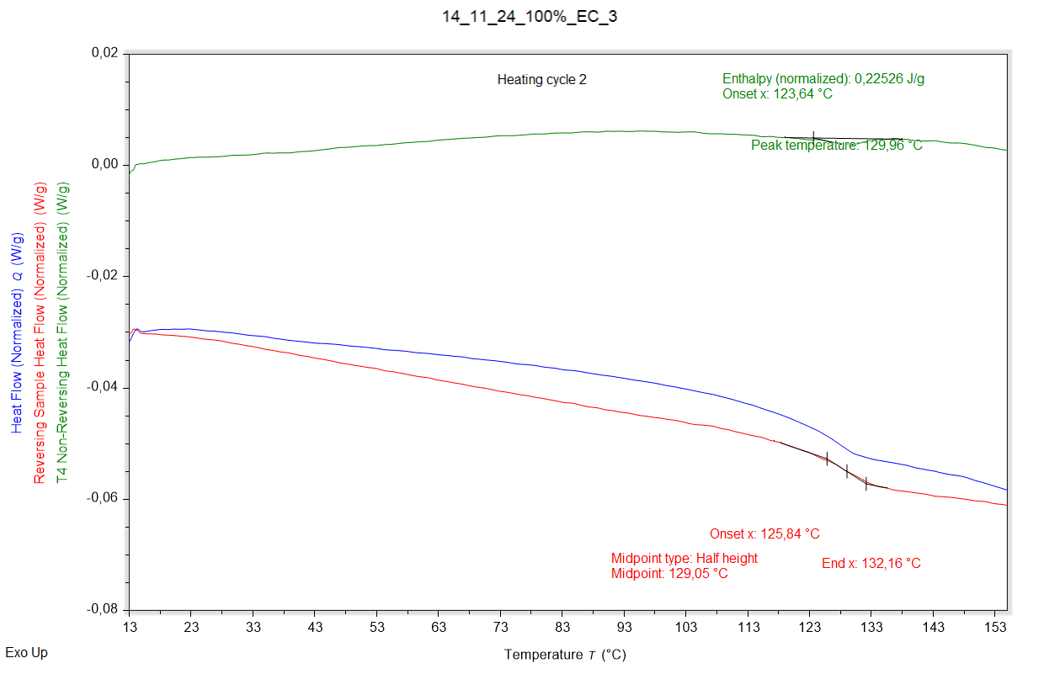

|  |  |  |  |
| --- | --- | --- | --- |
| Enthalpy recovery | Enthalpy recovery onset (°C) | Enthalpy recovery peak (°C) | Enthalpy recovery enthalpy (J/g) |
|  | 123,639 °C | 129,958 °C | 0,22526 J/g |

|  |  |  |  |
| --- | --- | --- | --- |
| Glass transition | Glass transition onset (°C) | Glass transition midpoint (°C) | Glass transition endpoint (°C) |
|  | 125,841 °C | 129,055 °C | 132,164 °C |